Government College of Engineering, Aurangabad

Synopsis of Project:

Ease In Banking

By

Krishna Patil

Enrollment No.: BE19F04F047

**Abstract**

The Online Bank Account Management System is an application for maintaining a person's account in a bank.

In this project I tried to show the working of a banking account system and cover the basic functionality of a Bank Account Management System. To develop a project for solving financial applications of a customer in banking environment in order to nurture the needs of an end banking user by providing various ways to perform banking tasks. Also to enable the user’s workspace to have additional functionalities which are not provided under a conventional banking project. The Bank Account Management System undertaken as a project is based on relevant technologies. The main aim of this project is to develop software for Bank Account Management System. This project has been developed to carry out the processes easily and quickly, which is not possible with the manuals systems, which are overcome by this software. This project is developed using Core Java , Java Swing and MYSQL use for database connection. The system is then designed in accordance with specifications to satisfy the requirements. The system design is then implemented with MYSQL, core JAVA ,SWING. The system is designed as an interactive and content management system. The content management system deals with data entry, validation confirm and updating whiles the interactive system deals with system interaction with the administration and users. Thus, above features of this project will save transaction time and therefore increase the efficiency of the system.

Introduction

The “Ease In Banking “ project is a model Internet Banking Site. Primary aim of this project is to provide basic information how to use ATM machine and Online transaction app. This project enables the customers to perform the basic banking transactions by sitting at their office or at homes through PC or laptop. The system provides the access to the customer to create an account, deposit/withdraw the cash from his account, also to view reports of all accounts present.. Thus today's banking is no longer confined to branches. E-banking facilitates banking transactions by customers round the clock globally. The primary aim of this to provide an improved design methodology, which envisages the future expansion, and modification, which is necessary for a core sector like banking. This necessitates the design to be expandable and modifiable and so a modular approach is used in developing the application software.

Synopsis

Bank Account Management System keeps the day by day tally record as a complete banking system. It can keep the information of Account type, account opening form, Deposit fund, Withdrawal, and Searching the transaction, Transaction reports, Individual account opening form, Group Account. The existing part of this project is; it displays Transaction reports, Statistical Summary of Account type and Interest Information.

Diagram:

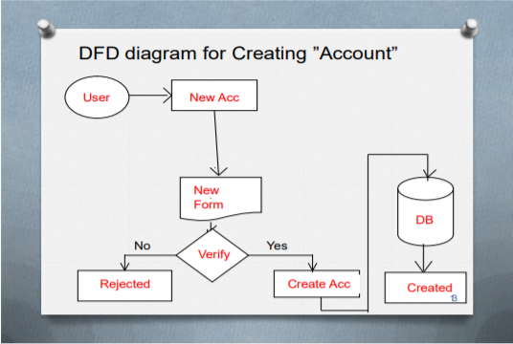

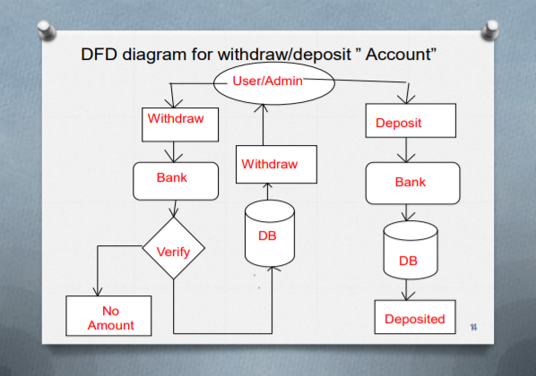

Overview of Project :

1. **Account Opening Form :**

This form is required to create or open an account of customer to our system. By filling the form correctly customer get’s account to our banking system and can take advantage provided by our system like, it gives basic idea how to use atm machine and online payment application for easy money transfer and other banking services.

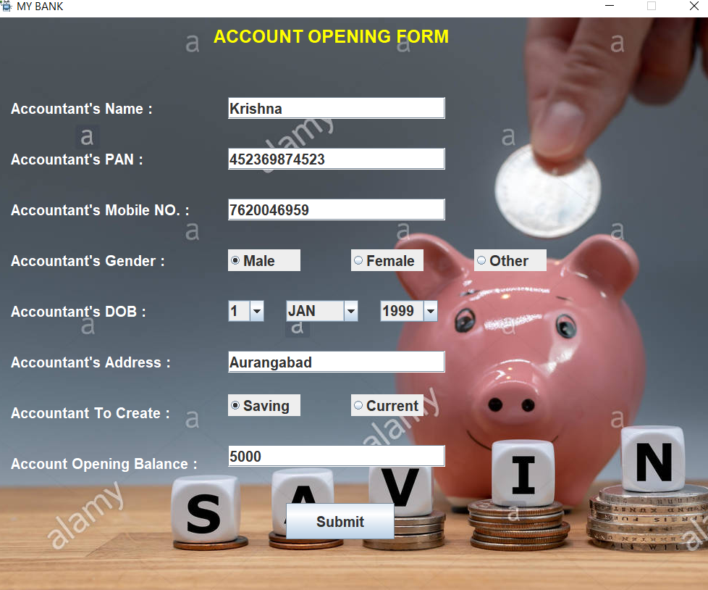

After submitting form with correct information pop message will generate confidential information like account number, atm card number, cvv etc. This information is used in the project wherever it require.

1. **Show Accountant Detail :**

This will show the account details of registered customers to admin.



1. **ATM GUI :**

This GUI helps person who doesn’t have enough knowledge how to use ATM machine and can make that person confident to use ATM machine. All features related to ATM are implemented in this GUI. Features like Cash Withdrawal, Ministatement, Check Balance, Fast Cash, Pin Change are added into it and this GUI is user friendly to use.

First window is for swapping the card :

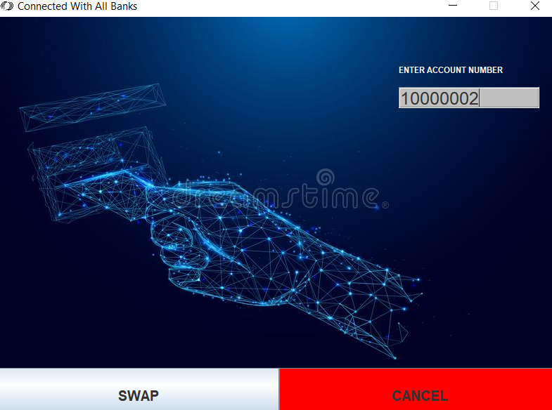

After entering the correct account number and by swaping the card control gets trasfer to main window of atm

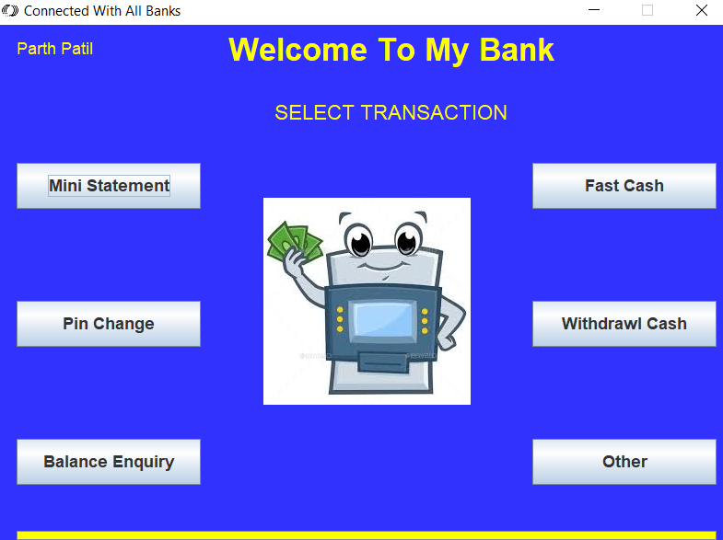

By choosing the required option, user can perform transaction.

There are some transaction details as shown below :

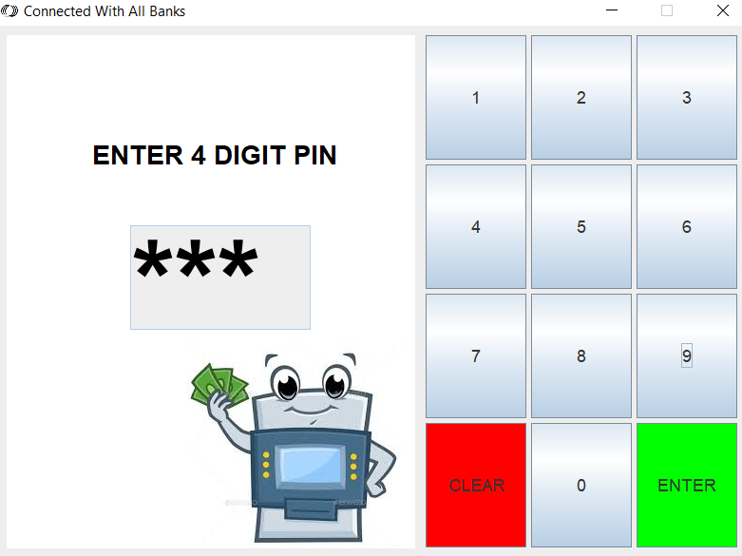

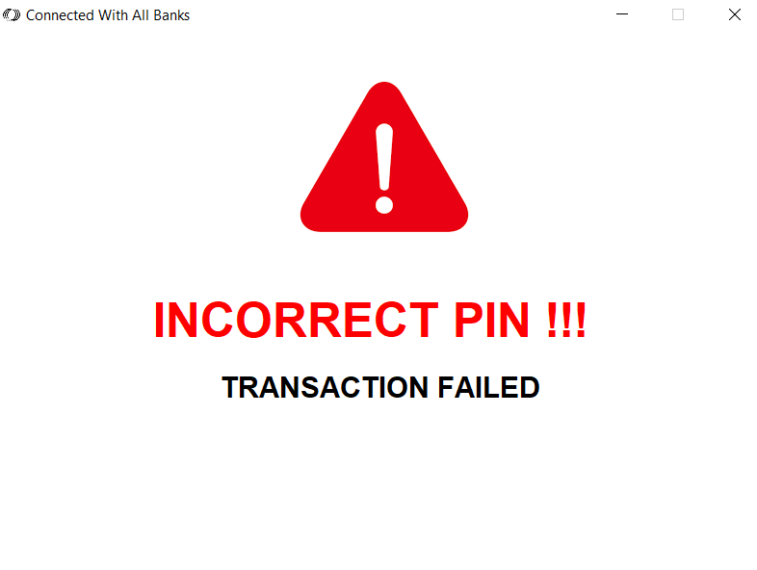

This window ask the operator to enter valid atm-pin for further transaction and if entered pin is invalid, error message will display on the screen.

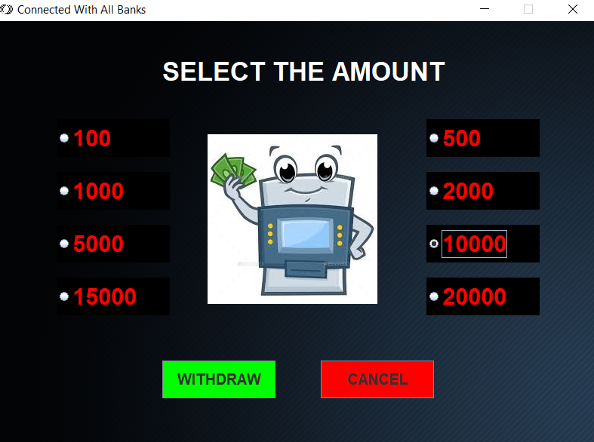

Fast cash window as shown above, by selecting appropriate amount and clicking Withdraw button cash gets withdrawl if balance is available, otherwise screen will show appropriate error message.

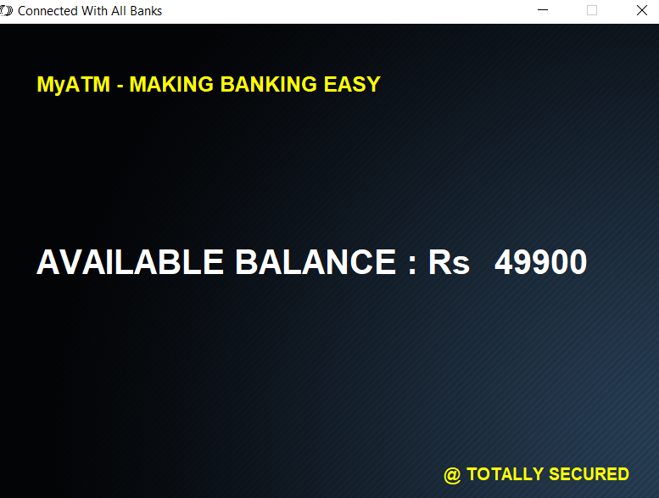

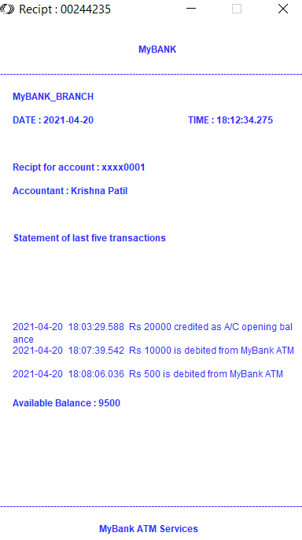

Atm machine generates this type of receipt, when operator wants to print ministatemet of there last five transactions.

Other required features are also added inside this GUI.

1. **Online Transaction Application (MyPay):**

This application is very user friendly and provides sufficient knowledge about other online payment transaction app like Google-Pay, PhonePe etc.

Information of this GUI is shown below :

App opening window :

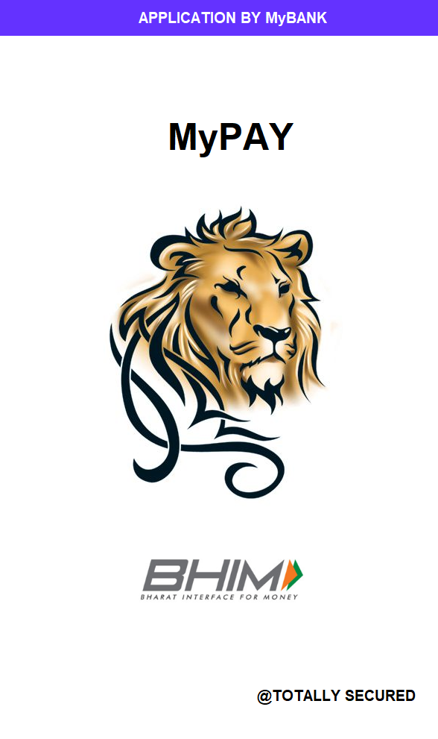

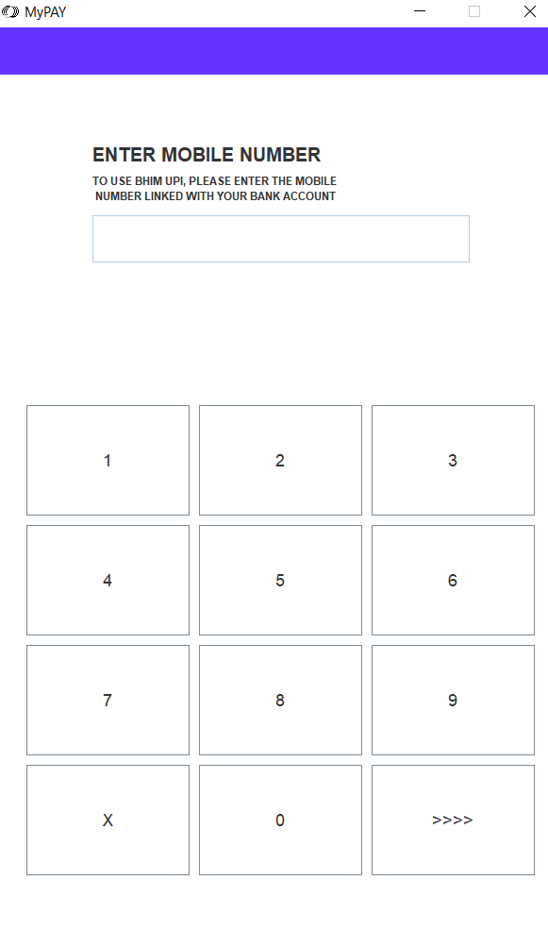

Above window is login window by entering mobile number customer will get logged in this app and if he/she is not registered then signup window will gets open.

**Main Window Of MyPay App**

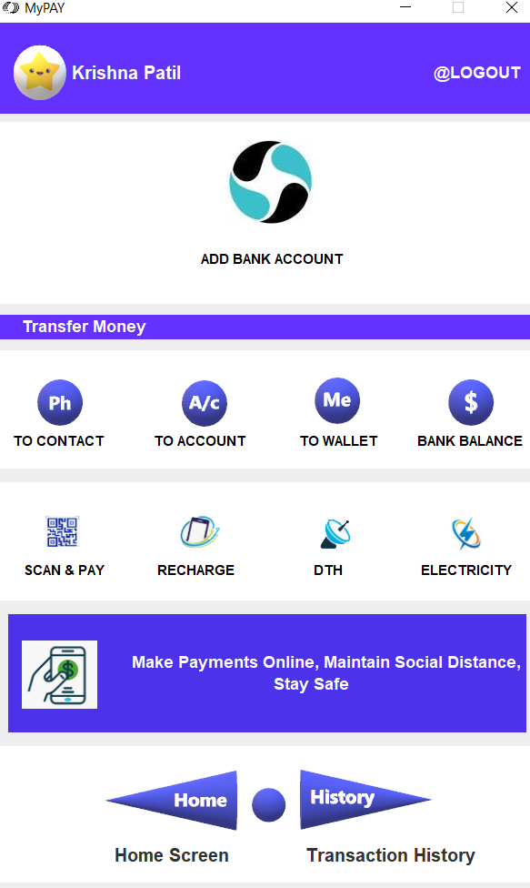

User can use above facilities through this GUI and gets friendly with it.

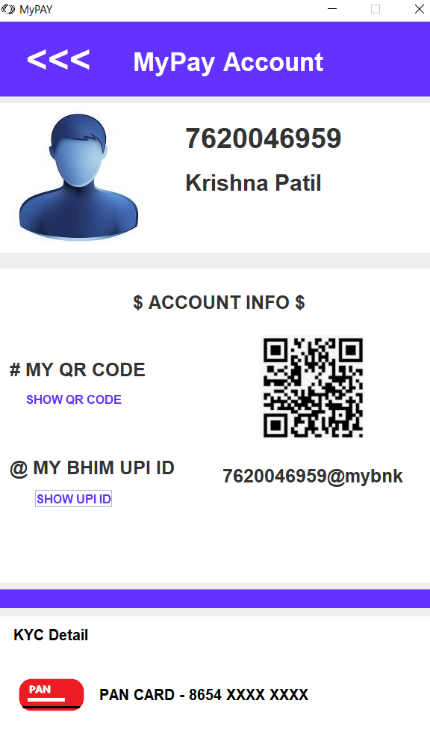

User’s information as shown on screen

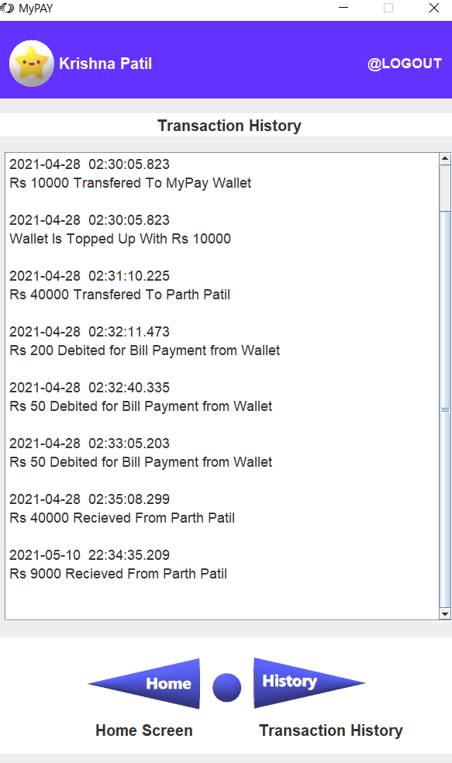

Transaction history of MyPay app gets displayed on the screen after clicking on History Button as shown above.

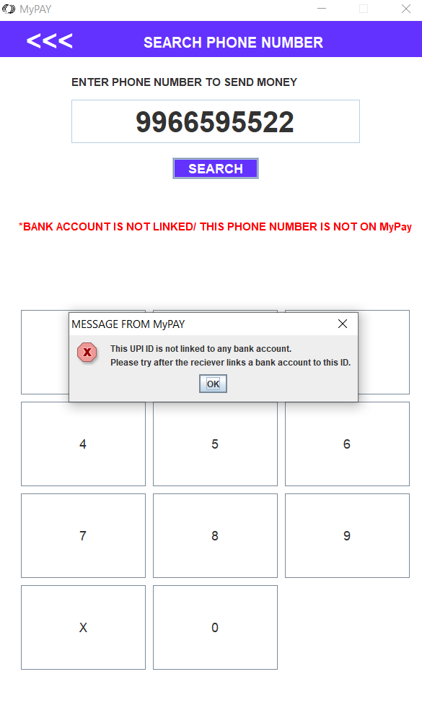

If any number/ account is not registered on MyPay then appropriate warning message gets dispayed on screen as shown in above picture.

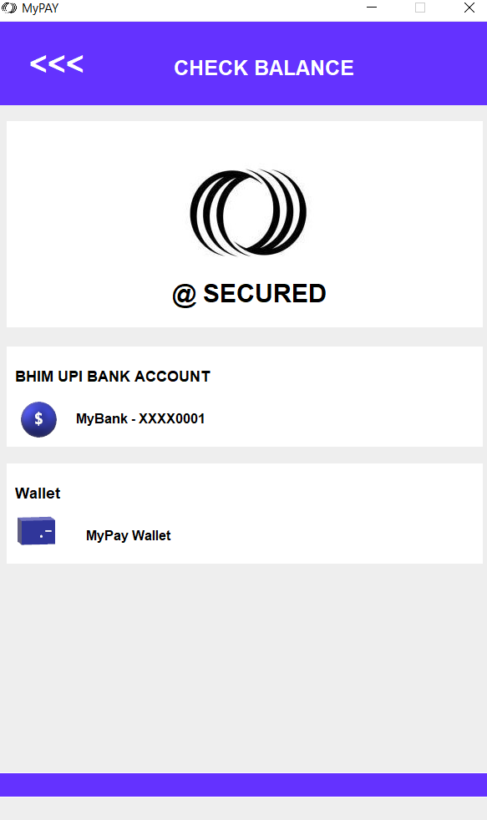

This window takes to required information about available cash, UPI pin is required for each and every transaction to make it safe.

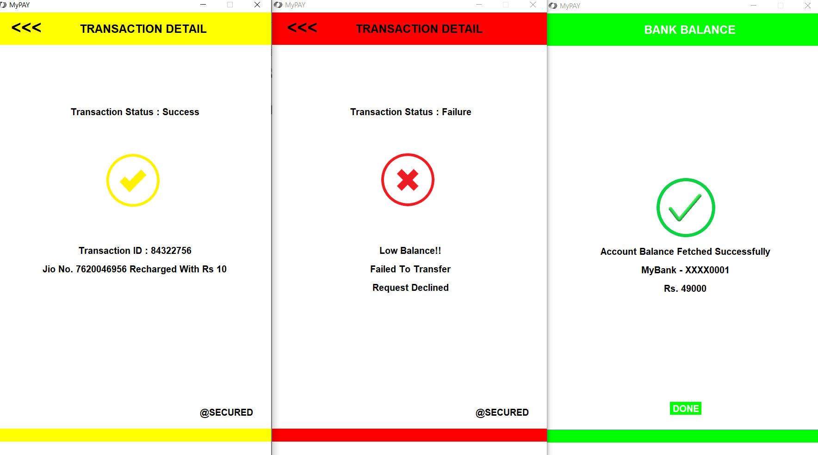

This messages gets displayed on screen for appropriate transaction like money transfer, payments and billing, fetching bank balance.

Error messages also gets displayed for low balance and for failed transactions.

**Conclusion :**

According to our project, user’s get familiar with such types of application and acquire lot of confidence for using such type of applications, which seems difficult to see.